1. 
2. 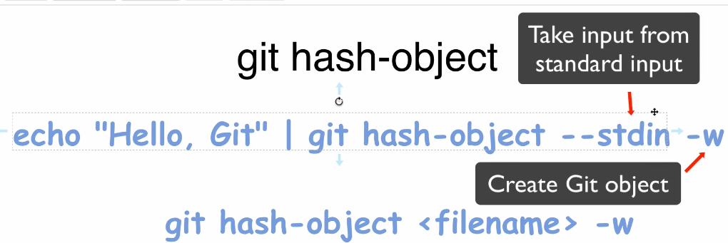
3. Let’s create a file on our system before running the command.
4. 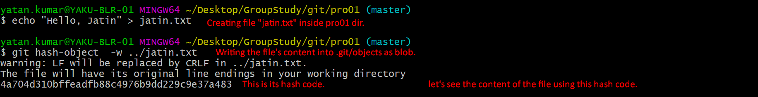
5. 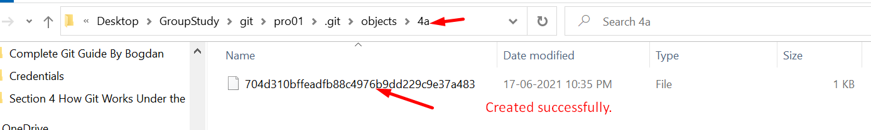
6. 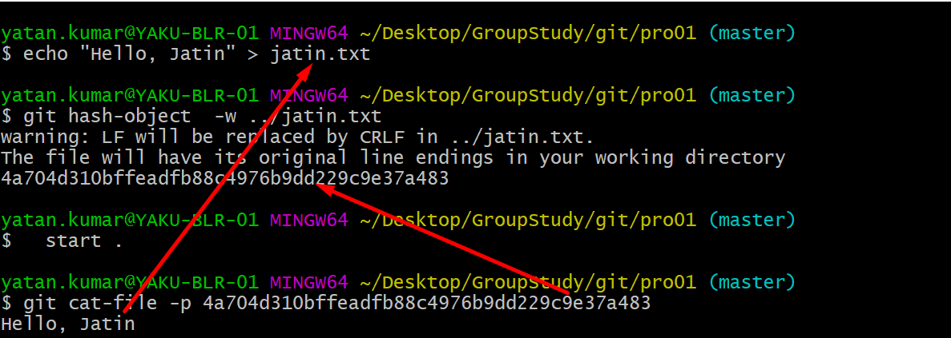
7. 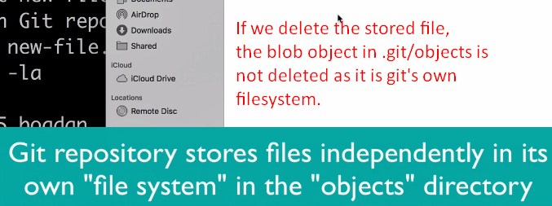
8. 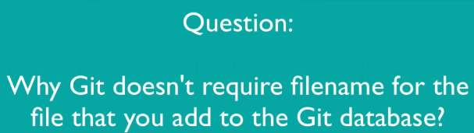
9. 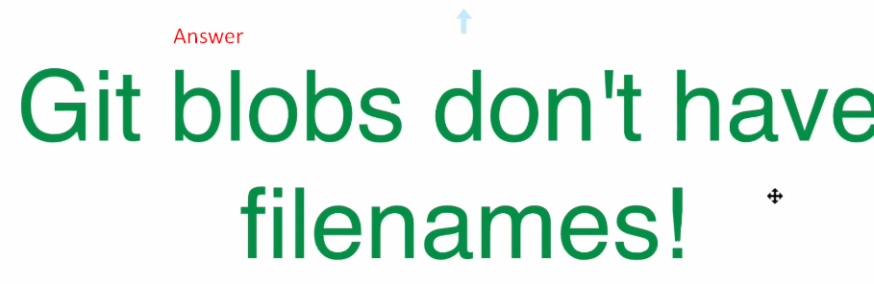
10. **Next Lec**:
    1. Why no file name?